A Review on High Gain DC-DC Converter Topologies for Hydro-Power Operated Plants and DC Load Applications

Chamundeeswari V 1, Blesso Abraham J 2, Arunkumar P 3

1Department of Electrical and Electronics Engineering, St. Joseph’s College of Engineering, TN, India, chamuvins@gmail.com

2Department of Electrical and Electronics Engineering, St. Joseph’s College of Engineering, TN, India, blessoabraham@gmail.com

3Department of Electrical and Electronics Engineering, St. Joseph’s College of Engineering, TN, India, embed.arunkumar@gmail.com

**Abstract**— Nearly 2700TWH energy is produced from hydro-power plants every year and supplies around 50% of electricity globally. A hydro-plant generates electricity by the water pressure that moves a large turbine which is coupled with a generator. The electricity is then transmitted to the grid lines for powering the loads. The hydro-plant produces AC output. To feed the DC loads, the generated AC power is rectified and fed to a DC-DC converter. In this regard, this paper projects the use of various DC-DC converter topological circuits in hydro-power operated plants. Super-lift converters are considered for analysis. Positive super-lift converter (PSC) and, modified negative Luo converter (MLC) are proposed in this work. Simulation is carried out using MATLAB and the results are validated with the theoretical calculations.

Keywords— **Hydro-operated plant; DC-DC converter; Super-lift; Positive super-lift converter, Modified Negative luo converter.**

1. INTRODUCTION

In a hydro-electric power plant, a dam is constructed across a river to create a reservoir. The energy from the water is used as hydro energy to generate electricity [1]. During the hydrological cycle, the water is collected from seasonal rain, streams and rivers. It is then used to run a turbine wheel. The kinetic energy is transformed into mechanical energy by the turbine and it drives a generator to generate electricity. Since the demand for DC power has increased now-a-days, the AC energy obtained from hydro-power is converted to DC and further fed to DC-DC converter. The need for DC energy has drastically increased now-a-days, due to the development of electric vehicles, lighting using LED’s, personal computers, DC drives and various others. The produced hydro-energy is converted into DC using a power electronic switching circuit namely the rectifier and then fed to a DC-DC converter to get a ripple-free DC. Many DC-DC converters are available which produces a regulated DC output. In this work, high gain converters are chosen, modelled and portrayed.

The hydropower generated is dependent on basically two parameters namely the rate of fluid flow and hydraulic head [2]. The latter is the water level’s height in the reservoir and the rate of fluid flow is the pressure variation in water flow with respect to time. The hydro power generated is given by the following equation,

$P=hrgk$

Where ‘h’ is the height of water, r is the rate of flow in m3, g is acceleration due to gravity in m/s2 and ‘k’ is efficiency constant which varies between value 0 and 1. The hydro-power plant has two systems majorly in it. One is the hydraulic turbine governing system and the other is the excitation system. The governing system can also be called as governor. It only acts as a hydraulic turbine controller. The water flow is varied by the governor through the turbine to control the speed or the output power. The speed of the generating unit and the frequency is also adjusted by the governor. The second major is the excitation system in a hydro plant. It provides the required DC current for the field windings of the generator and also helps in power regulation control [3]. The standard excitation voltages are 62.5, 125, 250, 375 and 500 V DC. AC power from the generator is converted into DC using a rectifier circuit. The ripple-free DC is obtained from various converter topologies discussed in this work. It can be fed to various DC loads.

In this work, Section II deals with the proposed system and section III explains the modelling of a hydro-power plant. Section IV explains different DC-DC converters taken for analysis and its detailed explanation in section V with positive super-lift converter along with its analysis based on different excitation voltage. Section VI portrays the concept of negative super-lift converter with its analysis. Section VII is dealt with hardware results followed by section VIII with conclusion.

1. PROPOSED CONFIGURATION

Fig. 1 shows the proposed configuration of hydro-operated plant with a DC-DC converter to feed DC loads. There are two major systems in hydro plants. One is governing system and the other is excitation system [4]. The governing system acts as a controller for the turbine part and the adjustment of frequency and the speed of the generator is carried out by it. It is called as hydraulic turbine governor system (HTG). The output from the governing system is the mechanical power (Pm)developed which is fed to the machine to generate electricity [5].

The governing system is a feedback system which senses the speed and power and provide a proper control action, if any deviation found from the reference or standard values of speed and power. The second major system is the excitation system which provides the field current for the generator windings. The generator generates AC power from the hydro-mechanical power. The rectifier is then used to convert AC power into DC power.

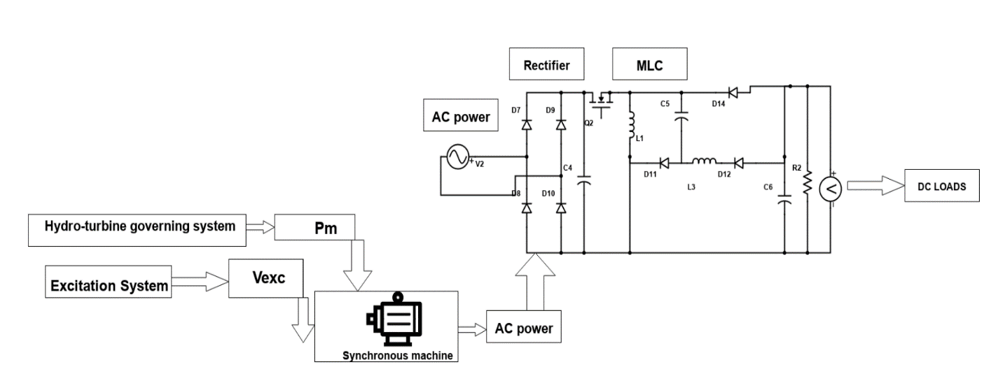

Fig. 1 proposed configuration of hydro operated plant

The rectified DC is fed as an input to a DC-DC converter. The DC-DC converters preferred in this work are positive and negative converters. Positive output super-lift converter namely PSC [6], is a positive converter and MLC is a modified negative luo converter. The positive and negative voltages are used in feeding DC loads, amplifier circuits and rig-lines.

1. MODELLING OF A HYDRO-POWER PLANT

The mathematical representation of a hydropower plant is a difficult process because there are numerous variables to be taken into account. A hydroelectric power plant has two subsystems. Specifically, the hydro-subsystem, which connects the reservoir region to the turbine. as well as the regulating system, which transfers kinetic energy to mechanical energy. Creating a comprehensive model for an entire hydro-power plant is intricate, as it requires modelling the reservoir, conduit, raceway, and turbine. This process involves formulating mathematical equations for each subsystem, a demanding task, particularly when defining the parameter values for each component. To streamline this, a simplified approach focuses on modelling the hydro-subsystem, drawing its characteristics from the dynamics of water in the raceway. The hydro power plant can be modelled as a single water time constant (Twater). It represents the acceleration time in the raceway between the dam and the turbine.

$Twater= \frac{l x v}{g x Ht}$ (1)

Where l is the raceway's length, v is the water speed, g denotes the acceleration due to gravity, and Ht is the total height of water in the raceway. This is a straightforward mathematical model but may not be suitable for longer raceways. Additional equations are developed to encompass the intricate aspects of a hydro-plant, addressing parameters such as energy output, water flow rate, turbine power, and efficiency. These equations also account for the water level in the tank and the time constant of the raceway. The energy value of the turbine is,

$E=\frac{2gHn}{R^{2}n2}$ (2)

Where ‘n’ is the turbine speed and ‘R’ is the turbine radius

The turbine water flow rate is given by,

$R= \frac{Q^{n}}{SR^{3 }n}$ (3)

Where Qn is the nominal flow rate and S is the turbine section.

The power value of the turbine is given by,

$P_{t= }\frac{2P_{mn}}{ρsR^{5}n^{3 }}$ (4)

Where $P_{mn}$ is the mechanical power and $ρ$ is the water density.

The efficiency value of the turbine is given by,

$T_{e= }\frac{P_{mn}}{ρgH_{n}Q_{n}}$ (5)

Where $Q_{n}$ is the net head of water.

The time constant of the raceway is,

${Tg}_{= \sqrt{\frac{LgSg}{gSch}}}$ (6)

Where Lg and Sg are geometry of the influent conduit and Sch is the surge tank section. Thus, various equations representing the hydro-turbine section were discussed.

1. DC-DC CONVERTERS WITH HYDRO-POWER OPERATED PLANT

Generally, the output power produced from hydro plant is AC. To get a regulated DC, it is rectified and fed to a DC-DC converter. In this regard, this section portrays different types of converters taken for analysis. A positive output [7-8] and a negative output DC-DC converter is interfaced with hydro-plants and its results are analysed. The positive converter namely positive luo converter (PLC) and the negative converter namely modified negative luo converter (NLC) are taken and analysed.

1. PLC WITH HYDRO-POWER PLANT

The output obtained from the hydro-power plant is AC power. AC power is converted into DC power using a rectifier circuit. The obtained DC is converted into the desired DC by using an DC-DC converter [9]. In this regard, to extract a high gain, ripple free DC from the rectifier circuit, a converter named positive super-lift converter is employed. It produces an output voltage, three times that of the input voltage. For example, if an input voltage of 12 V is applied, then it produces an output of +36V.High value DC can be used for various DC applications.

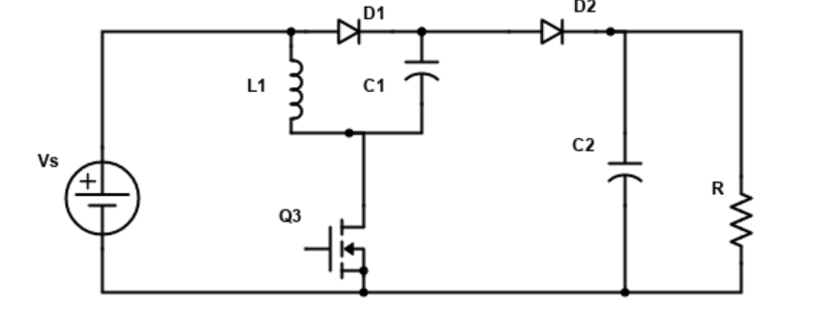

Fig. 2 Circuit diagram of PLC

Fig. 2 depicts the circuit diagram of PLC. It consists of a DC supply Vs, a MOSFET switch Q3, inductor L1, Capacitors C1 and C2, Diodes D1 and D2, and load resistance R. It works in two modes, on and off. The two modes are portrayed in fig 3 and fig 4.

1. On mode

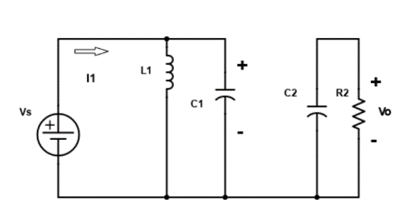

Fig. 3 On mode of PLC

During switch - on mode, as shown in fig 3, the current I1 passes through L1 and the capacitor also charges to Vs. The diode D1 is forward biased and diode D2 is reverse biased. The voltage across the load R is Vo and it is the capacitor C2 voltage.

1. 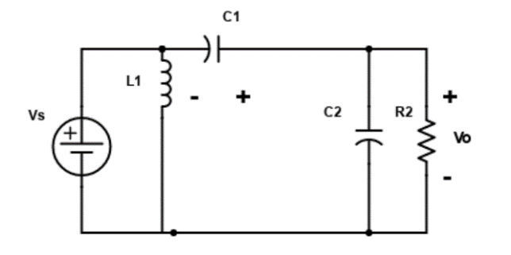Off mode

Fig. 4 Off mode of PLC

Fig 4 shows the off mode of PLC. During this mode, the switch is off. The inductor current decreases with a slope of Vs/L1, and diode D1 becomes reverse biased and diode D2 becomes forward biased. The same current flows through C1 and L1. The voltage across the load increases because of the discharge from all the passive components of the circuit during this mode.

1. Equations of PLC

The value of the inductor ripple current can be found from the charging and the discharging of the inductor L1. During on-state, the current through the inductor increases with a slope of Vs/L1 and during off ,it decreases with a slope of (Vo-2Vs)/L1.

The ripple current is given by,

$∆iL=\frac{Vs}{L1}DT =\frac{Vo-2Vs}{L1}\left(1-D\right)T$ (7)

Where Vs is the source voltage, Vo is the output voltage, DT is on-time duty cycle and (1-D)T is the off-time duty cycle.

The gain of the circuit is given by

$\frac{Vo}{Vs }=$ $\frac{2-D}{1-D}$ (8)

1. Variation of output power for different values of Vref of excitation system with PLC

PLC is simulated by acquiring input from a hydro-plant and the results are plotted. For different reference voltages, it is simulated and analysed. Vref is the excitation system voltage which acts as a reference for the field voltage of AC synchronous machine. It is varied and with the produced mechanical power (Pm) from the hydro-turbine, given as an input to the synchronous machine. The synchronous generator produces a three-phase voltage as its output for the given Pm and Vref. Vref is initially taken as 0.5 and it is varied to 0.7 and 0.9. When Vref is taken as 0.5 as shown in fig 5, the DC output from the rectifier is 13V. It is then given as an input to PLC. The PLC boosts 13V to 51V and give as its output. An enhanced gain is obtained and the boosted voltage can be used for various DC applications. For an Vref of 0.7 shown in fig.6, the obtained DC is 18V and the output of PLC is boosted to 72V. In the same way, the output voltage is boosted four times for an Vref of 0.9 as shown in fig 7. The voltage input to PLC becomes 23V and produces an output of 93V.Thus the variation in the excitation system brings an enhanced gain in the overall system.

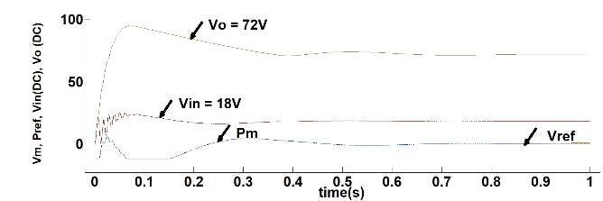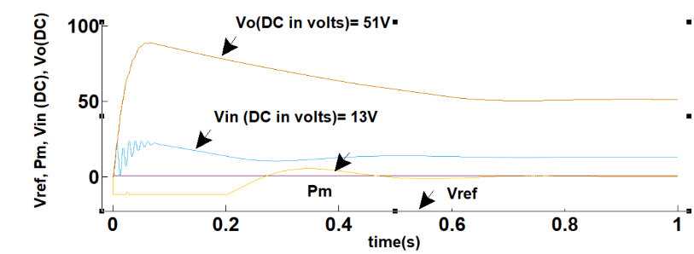Fig. 5 Vin and Vo of PLC with Vref=0.5 Fig. 6 Vin and Vo of PLC with Vref=0.7

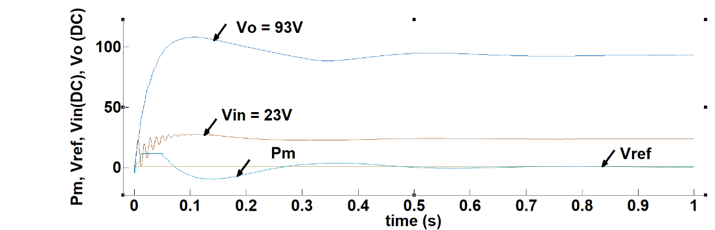

Fig. 7 Vin and Vo of PLC with Vref=0.9

1. MLC with a hydro-power plant

As the requirement for negative DC voltages exist in the field of telecom, rig lines, it can also be obtained from a hydro-plant by connecting a modified negative luo converter (MLC) with it [10]-[11]. The produced AC power from hydro plant is converted into DC power using a rectifier, and it is converted into a high value negative DC voltage using an MLC. It is a derived luo converter and produces a ripple free high gain DC. The converter is simulated with a hydro plant and the results are plotted in figures

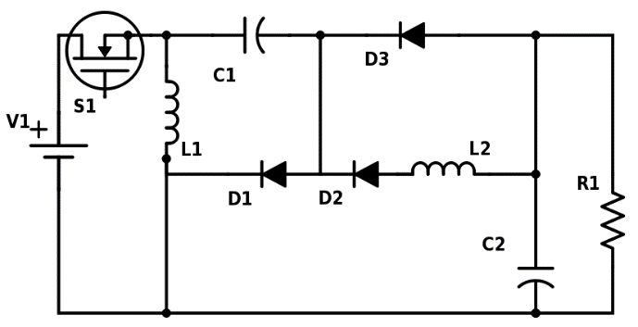

Fig. 8 Circuit diagram of Topology-3: MNOSLC

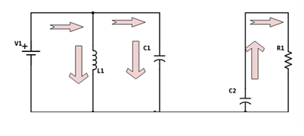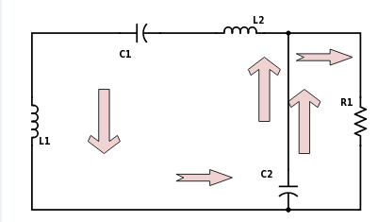

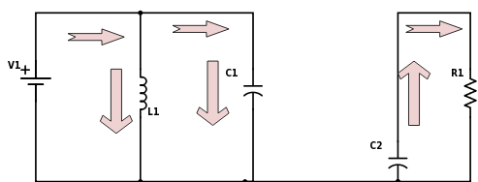



Fig. 9 Circuit diagram of Mode-1 Fig. 10 Circuit diagram of Mode-2

In mode-1, the switch S1 is activated between periods 0 and T. The source voltage causes current to pass via inductor L1 and capacitor C2 when the switch is closed. Because capacitor C2 provides no current impedance, it charges more rapidly than the inductor leading to the forward biasing of diode D1. As a result, charge accumulates in inductors L1 and L2, as well as capacitor C2. The discharging capacitor C1 keeps the load current constant throughout this time. As a result, the preceding cycle's energy kept in capacitor C1 is transmitted to the load.

In mode-2, between the periods ΔT and T, the switch S1 is deactivated. When the switch is open in this mode, the energy stored in the inductors L1, L2, and capacitor C1 is released across the nodal points of capacitor C2, thereby elevating the output voltage.

1. Equations of PLC

The gain equation is obtained as,

 (9)

The output voltage is given by,

 (10)

Where Vin and Vo are the input and output voltage and k is the duty ratio.

1. Variation of output power for different values of Vref of excitation system with MLC

MLC is simulated by acquiring input from a hydro-plant and the results are plotted. For different reference voltages Vref, it is simulated and analysed.



Figure 11 Three phase voltages from hydro- power plant

Figure 11 show the generated three phase voltage from a hydro operated power plant. Vab, Vbc and Vca are the generated voltages. Figure b shows the rectified DC from rectifier as Vrect and Vlc and Imlc are the output voltages of modified luo converter.

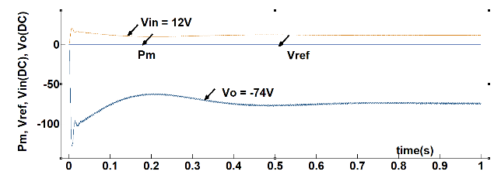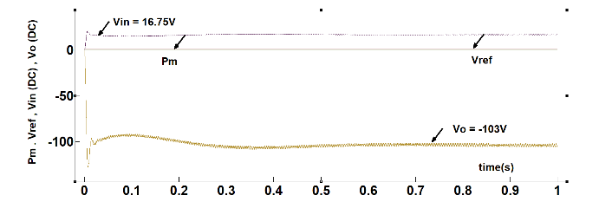

Figure 12 (a) Vin and Vo for Vref = 0.5v Figure 12 (b) Vin and Vo for Vref = 0.7v

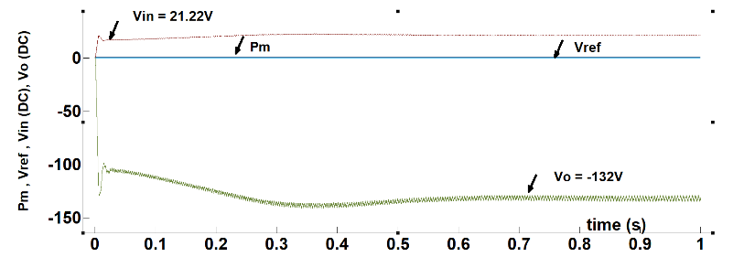

Figure 12 (c) Vin and Vo for Vref = 0.9v

Figure 12. Vin and Vo of MLC for different Vref values

MLC is negative luo converter which converts a positive DC input into negative DC output. It can be used for negative voltage applications. Vref is the excitation system voltage which acts as a reference for the field voltage of AC synchronous machine. It is varied and with the produced mechanical power (Pm) from the hydro-turbine, given as an input to the synchronous machine. The synchronous generator produces a three-phase voltage as its output for the given Pm and Vref. Vref is initially taken as 0.5 and it is varied to 0.7 and 0.9. When Vref is taken as 0.5 as shown in fig 12(a), the DC output from the rectifier is 12V. It is given as an input to MLC. The MLC boosts 12V to -74V and give as its output. It shows a ‘6’ times rise of output with respect to input voltage. An enhanced gain is obtained and the boosted voltage can be used for various DC applications. For an Vref of 0.7 as shown in fig 12(b), the obtained DC is 16.75V and the output of MLC is boosted to -103V. In the same way, the output voltage is boosted six times for an Vref of 0.9 as shown in fig 12(c). The voltage input to MLC becomes 21.22V and produces an output of -132V.Thus the variation in the excitation system brings an enhanced gain in the overall system.

1. HARDWARE RESULTS

This section discusses the hardware results of a developed modified negative super-lift converter. The six times rise of the output voltage for a given input is displayed here.

Figure 13 shows the input voltage of 3.1V fed to MLC and the output voltage obtained with a high gain is shown in fig 14 as -17.03V. Thus, a DC obtained from hydro-plant can be raised to six times using these lift converters.

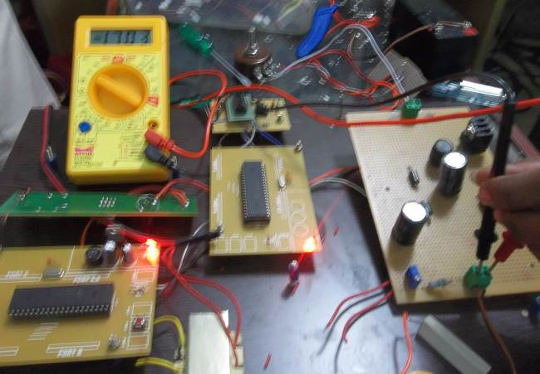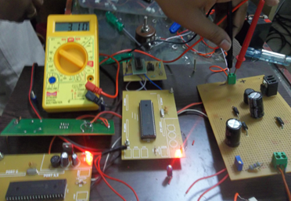

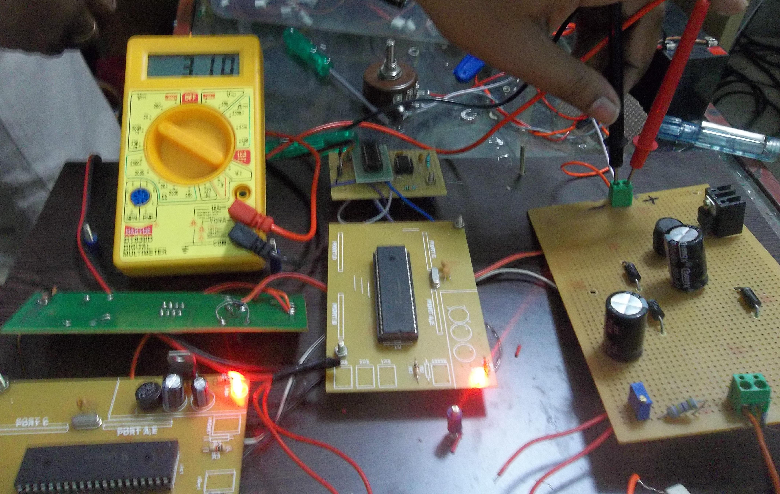

*Fig. 13 Input voltage of 3.1V Fig. 14 Output of MNOSLC=- 17.03V*

1. APPLICATION

A Positive Super-Lift Converter is a specialized DC-DC power converter primarily designed for high-voltage applications. Its specific applications include power supplies for systems requiring a voltage boost beyond the input voltage range, such as in automotive and aerospace industries. It's commonly used in electric and hybrid vehicles to efficiently step up the low-voltage battery power to higher levels required for motor drives. Additionally, it finds utility in renewable energy systems like solar inverters, where it enhances the conversion efficiency and allows for grid integration. This converter's ability to step up voltages efficiently makes it valuable in various applications demanding elevated voltage levels while maintaining energy efficiency. Modified Negative Luo Converters with an output of -48 volts have diverse applications in the realm of power electronics. They're commonly utilized in telecommunications equipment and data centres, where -48 volts is a standard voltage level for powering devices like routers, switches, and servers. This converter design is ideal for efficiently converting input power sources, such as batteries for cathode protection or other power supplies, to match the required -48V output, ensuring reliable and stable operation of critical communication infrastructure. Furthermore, these converters play a crucial role in the field of distributed power systems, enabling power distribution and management in scenarios where consistent voltage levels are essential for the seamless functioning of a wide range of electronic equipment, contributing to the reliability and stability of modern communication networks.

1. CONCLUSION

In today’s application field, DC loads play a vital role. In this regard, this work has projected the concept of deriving DC power from hydro-operated plants using DC-DC converters. Two types of converters namely a positive output and negative output converter is analysed and represented. The hydro-plant is modelled and its equations are analysed. It is interfaced with two types of DC-DC converter namely PLC and MLC and the results are displayed.

REFERENCES

[1] WalterGil-González, Oscar DaniloMontoya,AlejandroGarces, *“Modelling and control of a small hydro-power plant for a DC microgrid,”* Electric Power Systems Research, Volume 180, pp 1-6,2020.

[2] *Mini-hydro power plant for the improvement of urban water-energy nexus toward sustainability* - A case study, Journal of Cleaner Production, Volume 249, 10, pp 1-22, March 2020.

[3] P. Beires, M. H. Vasconcelos, J. A. Peças Lopes, *“Stability of autonomous power systems with reversible hydro power plants: A study case for large scale renewables integration,”* Electric *Power* Systems Research 158, pp 1-14, 2018.

[4] V. V. Markin, N. P. Kiselev & N. I. Kmotrikov, *“Mini, Micro, and Small Hydropower Plants are Returning to the Market,”* Power Technology and Engineering, volume 54, pp 494–499,2020.

[5] Michel Rezkalla, Michael Pertl &Mattia Marinelli, *“Electric power system inertia: requirements, challenges and solutions,”* Electrical Engineering volume 100, pages 2677–2693,2018.

[6] R. Saktheeswaran, D. Murali, *“Experimental validation of multi-loop controllers for two-level cascaded positive output boost converter,”* Journal of Power Electronics, volume 20, page 350–364,2020.

[7] Sethuraman S. Somalinga & Karuppiah Santha, *“Modified high-efficiency bidirectional DC–DC converter topology,”* Journal of Power Electronics volume 21, pages 257–268,2021.

[8] Fang lin luo, hong ye, *“Advanced DC-DC converters,”* CRC press,2004.

[9] Fang Lin Luo; Hong Ye, *“Positive output super-lift converters,”*IEEE Transactions on Power Electronics, Volume: 18, Issue: 1, Page(s):105 – 113,Jan. 2003,DOI:10.1109/TPEL.2002.807198

[10] Fang Lin Luo; Hong Ye, *“Negative output super-lift converters,”* IEEE Transactions on Power Electronics, Volume: 18, Issue: 5, pp 1113 – 1121, Sept. 2003,DOI:10.1109/TPEL.2003.816185

[11] Farzad Mohammad Zadeh Shahir, Ebrahim Babaei, Murtaza Farsadi, *“Extended Topology for a Boost DC–DC Converter,”* IEEE Transactions on Power Electronics, Volume: 34, Issue: 3, March 2019,Page(s):2375 – 2384,DOI:10.1109/TPEL.2018.2840683

[12] German Ardul Munoz-Hernandez, Sa'ad Petrous Mansoor, Dewi Ieuan Jones, “*Modelling and Controlling Hydropower Plants*,” 13 June 2012, Springer London, ISBN:9781447122913, 1447122917.

[13] P. Drtinaand and M. Sallaberger, *“Hydraulic turbines—basic principles and state-of-the art computational fluid dynamics applications,”* ProcInstnMechEngrs, Volume 213 (C), 1999

[14] Singh M and Chandra A, “*Modeling and Control of Isolated Micro-Hydro Power Plant with Battery Storage System*,” National Power Electronic Conference, Roorkee, India, 2010.

[15] L. N. Hannett, B. Fardanesh, *“Field tests to validate hydro turbine-governor model structure and parameters,”* IEEE Transactions on Power System, Volume 9(4) , 1994/

[16] Ramey D. G. and Skooglund J. W, *“Detailed hydro governor representation for system stability studies,”* IEEE Trans on Power Apparatus and Systems, 89:106–12, 1970.